Ref – Maheswari UTN, Sindhu SJ. Confocal Microscopic Analysis of Lip Prints-A Novel Approach. Anil Aggrawal's Internet Journal of Forensic Medicine and Toxicology [serial online], 2020; Vol. 21, No. 2 (July - December 2020): [about 16 p]. Available from: http://anilaggrawal.com/ij/vol_021_no_002/papers/paper001.html. Published as Epub Ahead: May 23, 2017.

Access the journal at - http://anilaggrawal.com

************************************************************************

CONFOCAL MICROSCOPIC ANALYSIS OF LIP PRINTS-A NOVEL APPROACH
1. DR.UMA MAHESWARI.T.N, 2.SENTHAMIL SINDHU.J
1. PROFESSOR, DEPARTMENT OF ORAL MEDICINE AND RADIOLOGY, SAVEETHA DENTAL COLLEGE.
2. INTERN, BDS, SAVEETHA DENTAL COLLEGE.
umasamsi@gmail.com
ABSTRACT:
AIM: This study aims on morphological imaging of type I, II, III, IV and V patterns of lip prints using Confocal microscopy.
OBJECTIVES: To analyze whether con focal microscopic analysis of lip prints yields better visualization of each type of lip prints in each part of lip
To ensure deep and specific analysis of each type of lip prints to find any significant difference other than morphological pattern.
METHODOLOGY: Lip prints were taken using lipsticks and glass slide; the slides were subjected to confocal microscopy for sectional imaging of all the 5 types of lip print patterns for their complete morphological imaging analysis.
RESULTS: Confocal microscopic analysis of each type of lip print proved that there are multiple types of lip prints in each compartment of the lip. Hence such imaging modalities should be mainly used in criminalization to compare the lip prints of the suspects for identification of the criminal.
KEY WORDS: lip prints, digitalization, confocal microscopy, morphological imaging, forensic investigation.

INTRODUCTION:
Confocal microscopy was a paradigm shift from conventional microscopy developed and patented by Marvin Minsky in19559, ¹ to provide very high quality images with fine details and improvised contrast. There are different advanced techniques used in con focal microscopic analysis like high frequency ultra sound reflectance con focal microscopy, optical coherence tomography, fluorescence, live real time microscopy etc. laser confocal microscopy is one of its kind used for obtaining high resolution not only 3d images but also 4d ² which was first introduced in 1980 by M.Petran and A.Boynde ³. It has been used for the diagnosis of structural abnormalities in the field of dermatology⁴.Confocal microscopy has been used in forensics for imaging the marks on bullets and cartridge cases that were otherwise not easily seen using conventional light microscopy. Even though the confocal microscopy has been used in identification of various forensic pathologies to screen the molecular abnormalities its use in cheiloscopy has not been described by any forensic odontologist. This paper aims in describing the use of confocal microscopy in detailed analysis of lip prints which can be used for criminal investigation.

MATERIALS AND METHODS:
This study included 10 individuals whose lips were carefully examined for any congenital or developed abnormalities. Each individual were informed in detail about the procedure and an inform concern was collected form them. Lip prints can be collected in different ways by applying lip stick and recording in tracing sheet, ⁵ or using tissue papers, ⁶ adhesive tapes⁷, scotch tapes⁸ and in bond papers⁹ .in this study lip prints were made by applying lip stick and recording it in micro slides since the lip prints had to be analyzed under microscope. The recorded lip prints were air dried and preserved in a slide box. The samples were subjected to laser scanning confocal microscope for analysis.
METHODOLOGY: Lips of each individual were cleaned with wet cotton and dark pink lip stick was applied with the help of ear buds starting from the border towards the center with the mouth wide open. The subjects were asked to keep their lips in close contact and lip prints were recorded using micro slides with the subjects made to stand in an upright position. The lip prints were recorded by applying equal pressure and pressing the glass slides against the subjects lip from right side to the left side through the center, after which the lips were cleaned with a wet tissue. All the 10 lip print samples were divided into 12 parts, ⁵ for manual analysis of the different types of patterns as classified by Suzuki and tsuchihashi; ¹⁰from which only 5 parts from different samples which had characteristic type I-V patterns were selected and were further divided into 9 compartments and analyzed under laser scanning confocal microscope in 10x resolution for detailed imaging of each type. The images captured were analyzed for detailing of each type of lip print pattern.
Figure1:
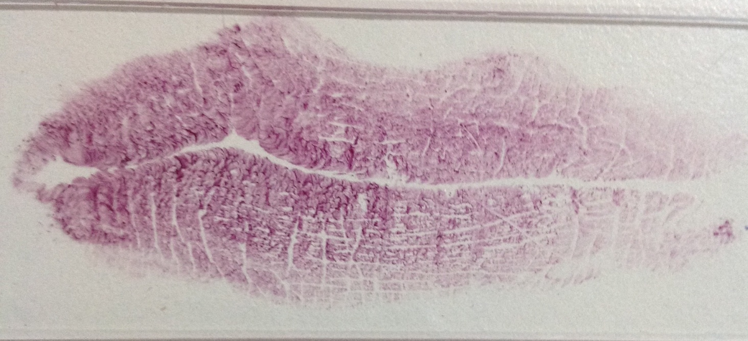
Lower left lateral
Lower right lateral
Lower right middle
Lower left central
Lower left middle
Upper left lateral
Upper left middle
Upper left central
Upper Right central
Upper Right middle
Upper Right lateral

RESULTS:
In a laser scanning confocal microscope the images can be viewed either under white or black background and the white and black backgrounds can be superimposed which is seen under a grey background as shown in figure(2).The images are seen in black color against white background , red color against black background and appears pink in the grey background. The image against black back ground is comparatively clear than the others. The areas with lip stick in the sample are seen red in color and the grooves are seen as black areas in the microscope images. The lip print patterns type I-V as seen under the microscope are depicted in figure (3-8). In this study it was found that there was more than one type of lip print pattern found in a single compartment as shown in figure (9). The lip prints can be viewed in different depth up to 20µm as shown in figure (10) and it was found that the quality of the image is better in the middle whereas the superficial and deep layers show poor quality images. The detailed imaging of each type of lip print has shown the characteristic appearance of each type of lip print pattern. Type I lip print patterns showed continuous black areas without any divisions in the sides. Type II pattern showed continuous black areas with divisions in the sides. Type III pattern showed adjacent continuous black areas which had divisions in the sides that intersected each other at a point. Type IV pattern showed vertical and horizontal black areas that intersected each other and had fence like appearance. Type V pattern showed irregular red and black areas similar to a cluster of dots. Areas containing incomplete horizontal and vertical lines which are almost parallel and hardly intersect were also seen. This shows the uniqueness of each type of lip print pattern.
Figure 2:
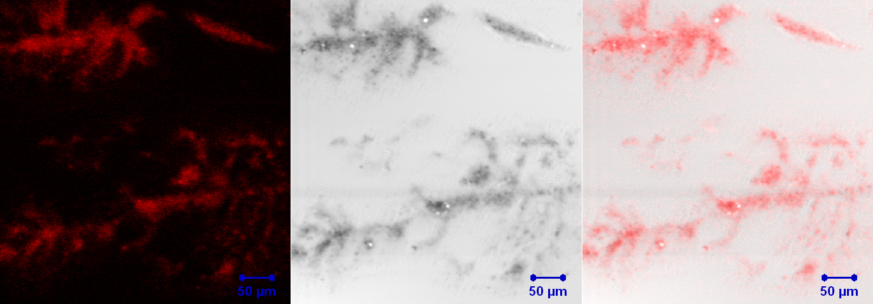

Figure 3: TYPE I-clear cut grooves running vertically across the lip
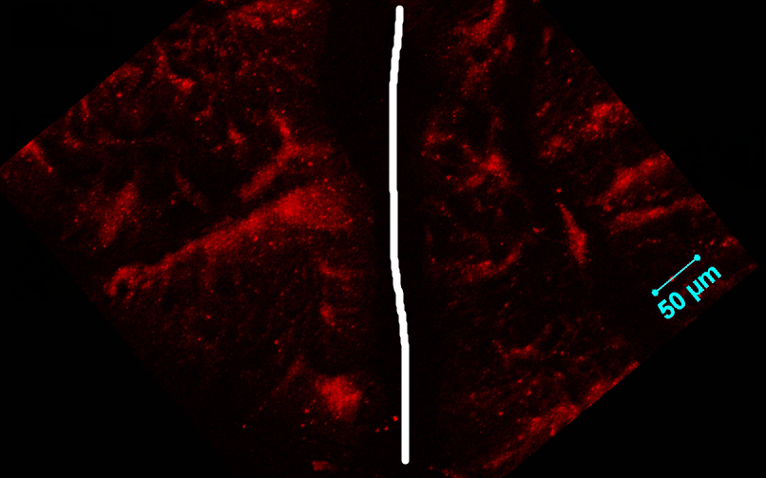
TYPE I

Figure 4: TYPE II-grooves forking in their course
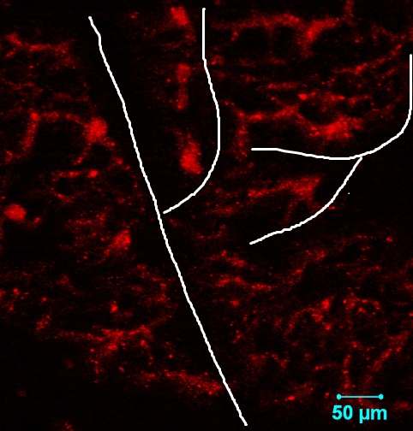
TYPE II

Figure 5: TYPE III-forked grooves intersect
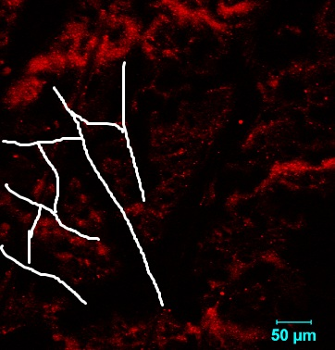
TYPE III

Figure 6: TYPE IV-grooves are reticulate
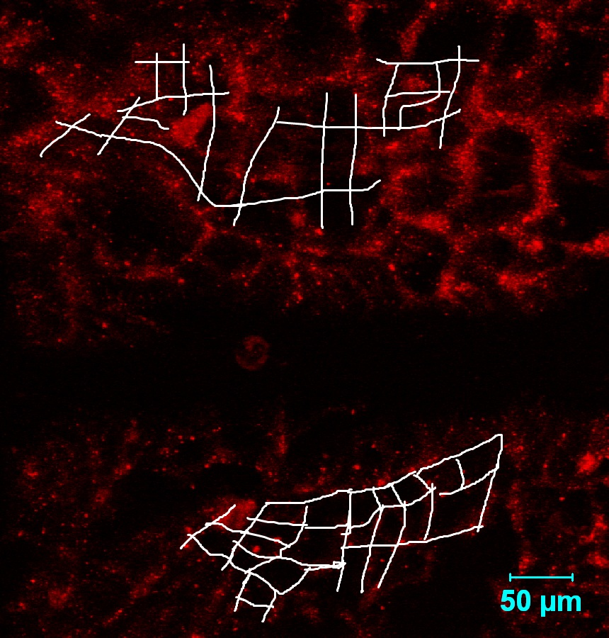
TYPE IV
Figure 7: TYPE V-grooves do not fall into any type I-IV and cannot be differentiated morphologically
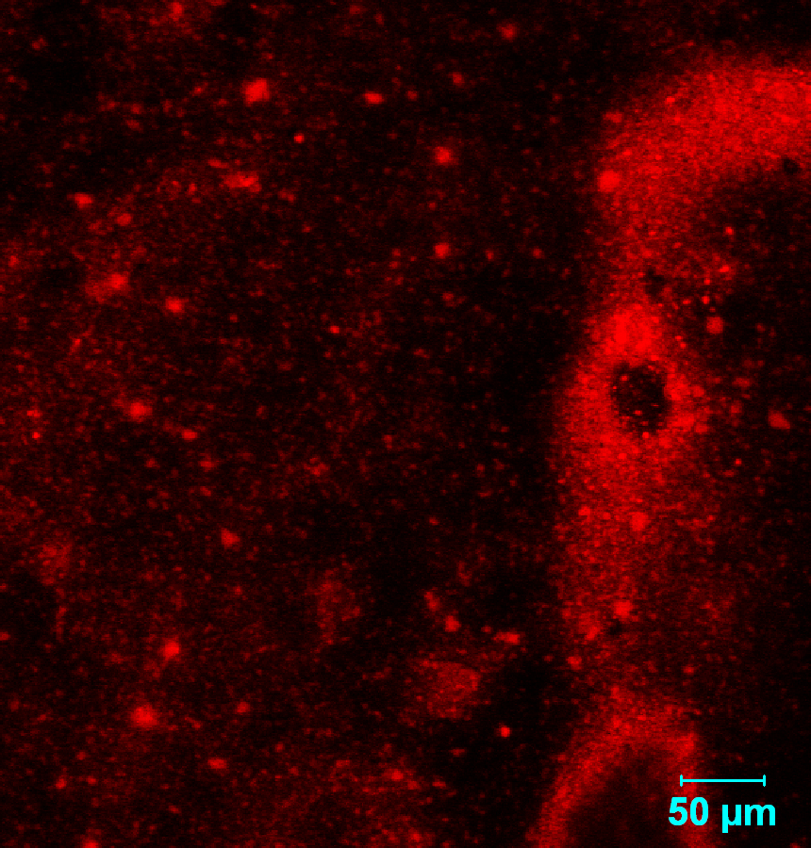
TYPE V

Figure 8: Different type V pattern-incomplete horizontal and vertical grooves
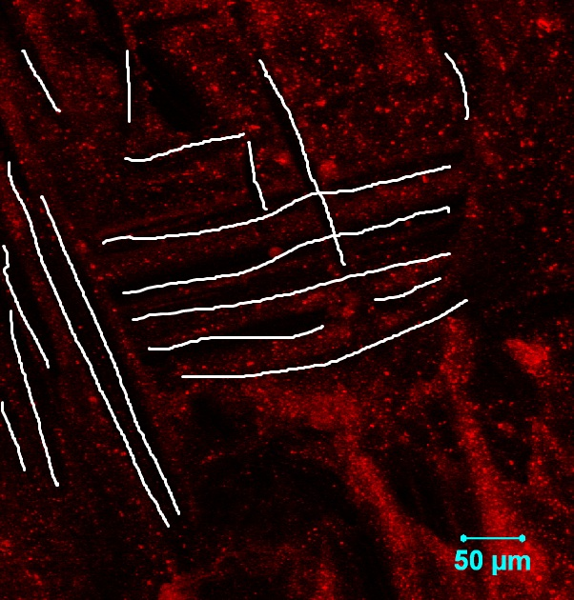
TYPE V

Figure 9: Different types of lip print pattern in a single compartment
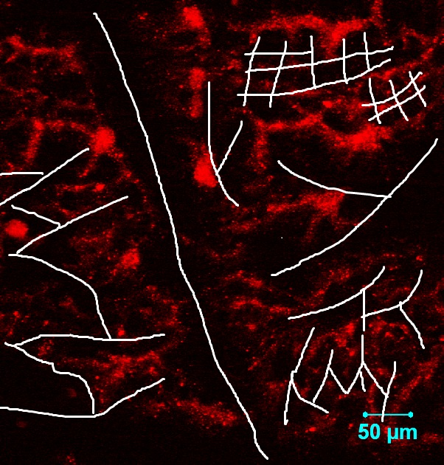
I
III
IV
II
II
III

Figure 10: Z-sections of a compartment of lip print sample showing cross sectional images at different depth up to 20µm
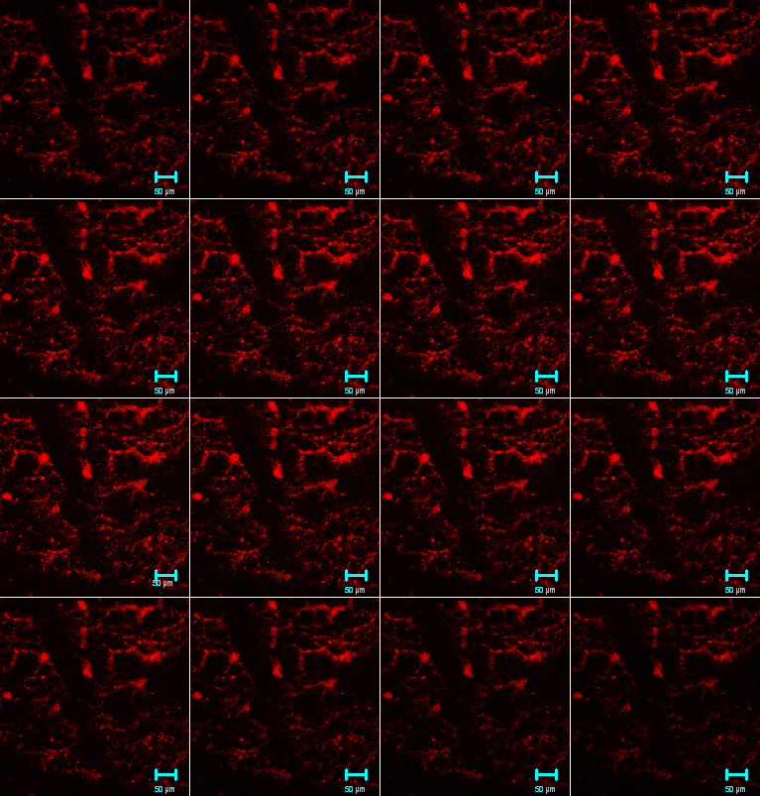

DISCUSSION:
Cheiloscopy is becoming one of the fields in which researchers show immense interest in. The importance of lip prints has been studied from very old days dated back from 1902, by R.Fischer.¹¹ More extensive studies on the uniqueness of lip prints was given by two Japanese scientists, Yasuo Tsuchihashi and Kazuo Suzuki in 1970; ¹⁰ the classification of lip print patterns given by them is widely used in practice till date because of their simplicity and accuracy ¹²⁻¹⁴. The analysis of lip prints was done in four quadrants initially by Yasuo Tsuchihashi and Kazuo Suzuki.¹⁰ Whereas the analysis of lip prints has been done by dividing the lip into 12 parts by T.N.Uma Maheswari and N.Gnanasundaram.⁵ This study is one of its kind in which the 12 parts of the lip print sample is further divided into 9 compartments for the analysis of finer details of the lip print pattern. Also the use of confocal microscopy in analysis of lip print samples has been emphasized for identification and comparison of lip prints in suspicious criminal investigation procedures. Confocal laser scanning microscopy (CLSM) is a new technique for microscopic imaging, in which the samples can be viewed in transverse sections and can be used for three-dimensional reconstruction. This microscope presents higher spatial resolution than the conventional light microscope. As a precision instrument for the microscopic image, it plays an important role in forensic pathology. Laser scanning confocal microscopy has been used in forensic sciences for investigations including terminal ballistics and various pathologies like neonatal hypoxic-ischemic lesions and sudden cardiac death.¹⁵ Objects under a confocal microscope can be viewed in a four-dimensional space (4D microscopy, xyzt) via a spatial analysis, repeated in time, and then combined with the spectral characterization of luminous signals coming from samples under examination (five-dimensional, 5D microscopy: xyztλ). By combining additional technologies such as fluorescent lifetime imaging (FLIM)-based analysis, the capabilities of CLSM have been further extended so that now, in some cases, it is possible to speak of six-dimensional microscopy.¹⁶ The samples were analyzed in each compartment to find for different types of lip print pattern in a single compartment which has not been attempted by any forensic investigators. The study also aimed in detailing each type of lip print pattern and has proved the uniqueness between each type of lip print pattern which has never been attempted by any of the researchers. It was also found that there were incomplete vertical and horizontal type of lip print patterns as described by Magda Ahmed El Domiaty, et al; ⁶ which was grouped under type V lip print classification by Uma Maheswari.T.N and Gnansundaram.N .⁵ Even though the confocal microscope can be advantageous in detailing of the lip print patterns it has its own limitations and disadvantages such as the z-sections can show images only to a depth of 20µm and it is time consuming and expensive respectively.

CONCLUSION:
Images under laser scanning confocal microscope show greater detailing of each type of lip print pattern and prove their uniqueness.
In depth analysis of lip print samples facilitates clear view of the lip prints and at different depths.
This imaging modality can be used for criminal investigation procedures but cannot be used for personal identification because its time consuming and expensive when compared to other imaging modalities.
In crime investigation where the latent lip prints are developed for analysis if lip prints of two suspects appear to be similar in manual analysis the confocal microscopic analysis can help in detailed imaging of the lip prints and thus avoiding bias.

REFERENCES:
1.Adobi Nwaneshiudu, Christiane Kuschal , Fernanda H Sakamoto, Rox Anderson R, Kathryn Schwarzenberger , Roger C Young .Introduction to confocal microscopy. Journal of Investigative Dermatology (2012); 132:1-5.
2. Lucitti JL, Dickinson ME .Moving toward the light: using new technology to answer old questions. Pediatr Res (2006); 60:1–5.
3. Boyde. A. Bibliography on confocal microscopy and its applications. Scanning (1994); 16:33–56.
4. Alejandra Garcia-Hernandez, Rodrigo Roldan-Marin, Pablo Iglesias-Garcia, Josep Malvehy. In Vivo Noninvasive Imaging of Healthy Lower Lip Mucosa: A Correlation Study between High-Definition Optical Coherence Tomography, Reflectance Confocal Microscopy, and Histology. Dermatology Research and Practice Volume (2013) July 28; 1-8.
5. Uma Maheswari.T.N, Gnanasundaram.N. Role of lip prints in personal identification and criminalization. Anil Agarwal’s internet journal of forensic medicine and toxicology (2011); 12(1).
6. Magda Ahmed El Domiaty, Sami Awda Al-gaidi, Ahmed Abdelmoneim Elayat, Maha Diaa Eldein Safwat, Sherief Ahmed Gala. Morphological patterns of lip prints in Saudi Arabia at Almadinah Almonawarah province. Forensic science international. (2010) May 27; 179.e1-9.
7. Augustine.J, Barpande.S.R, Tupkari.J.V.Cheiloscopy as an adjunct to forensic identification: A study of 600 individuals. Journal of forensic odontology. (2008); 27:44-52.
8. Rachana v.Prabhu, Ajith Dinkar, Vishnudas Prabhu .Digital method for lip print analysis: A new approach. Journal of forensic dental sciences. (2013); 5:96-105.
9. Padmavathi.B.N, Ramapal Singh Makkad, Rajan.S.Y, Gopi Krishna koli .Gender determination using chelioscopy. Journal of forensic dental sciences. (2013); 5:123-8.
10. Tsuchihashi Y.studies on personal identification by means of lip prints. Forensic sci (1974); 3:233-48.
11. Kasprzak J. Possibilities of cheiloscopy. Forensic Sci Int (1990); 46:145-51.
12. Text book of forensic medicine and toxicology, by Anil Aggrawal, (Kindle, 2015).
13. Text book of forensic medicine and Ayurveda, by Anil Aggarawal, (Kindle, 2016).
14. Text book of forensic medicine and toxicology for homeopathy, by Anil Aggrawal, (Kindle, 2016).
15. Emanuela Turillazzi , Steven B. Karch , Margherita Neri , Cristoforo Pomara ,Irene Riezzo , Vittorio Fineschi. Confocal laser scanning microscopy. Using new technology to answer old questions in forensic investigations. Int J Legal Med (2008) 122:173–177.
16. Braet F, Ratinac K Creating next generation microscopists: structural and molecular biology at the crossroads. J Cell Mol Med (2007); 11:759–763.

